Business Procurement Analytics
1. Project Overview
This project analyzes procurement operations using a dataset of 5,200 purchase orders (POs) from 2022 to 2024. Procurement plays a critical role in ensuring smooth business operations by sourcing goods and services; however, challenges such as rising costs, supplier risks, delivery delays, and off-contract spending can reduce efficiency and strain budgets.
The goal of this project is to help organizations gain clear visibility into spending patterns, evaluate supplier performance, track savings, and identify compliance issues. By uncovering key insights from procurement data, this analysis supports better decision-making, risk reduction, and improved operational efficiency.
2. Dataset Summary
- Rows: 5,200
- Columns: 57
- Key Features:
- Purchase Order - PO: PO Number, PO Date, PO Year, PO Quarter, PO Month, PO Type, PO Status.
- Supplier Details: Supplier ID, Supplier Name, Supplier Country, Supplier Region, Supplier Tier, Supplier Status, Supplier Risk, Supplier Latitude, Supplier Longitude, Preferred Supplier, Local International, Supplier ESG Score.
- Item Details: Item Code, Item Description, Category, Sub Category, Unit of Measure, Quantity.
- Financial & Budget Data: Unit Price, Discount Pct, Discount Amount, Tax Pct, Tax Amount, Line Total Gross, Line Net, Line Total Inc Tax, Currency, Budget Unit Price, Budget Total, Savings Amount, Savings Pct.
- Delivery & Timeline: Requested Delivery, Actual Delivery, Days Late, On Time Delivery, Lead Time Days.
- Internal/Department Info: Department, Cost Centre, Requestor Name, Approver Name.
- Contract & Invoice/Compliance: Contract ID, Contract Type, Contract Start, Contract End, Payment Terms, Invoice Status, Payment Status, Invoice Match Type, Maverick Spend, Single Source Flag.
3. Data Analysis using SQL
We performed structured analysis in SQL Server to answer key questions and delve deeper into the interplay between variables
- How has spending behavior changed over the years? Are there any seasonal patterns that influence ordering behavior?
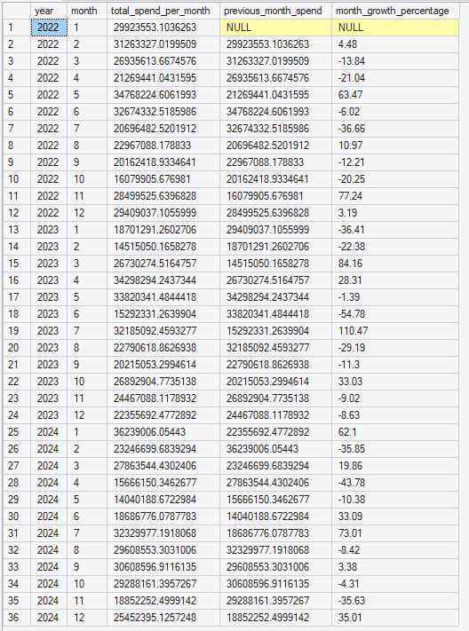

- "Where is the money going?": Top 5 product categories, departments, suppliers, or regions account for the highest share of spending?
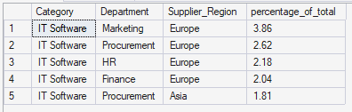
- Budget control: How much does actual spending deviate from the budget? Which categories consistently exceed their allocated limits?
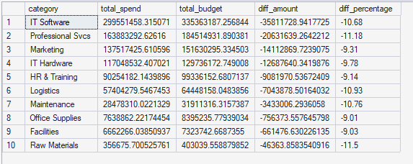
- Measuring negotiation effectiveness: Which projects or contracts are generating the greatest cost savings for the company?
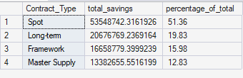
- Supplier profile: What are the risk levels, tier classifications, and ESG scores of the top 5 suppliers accounting for the highest share of spending?
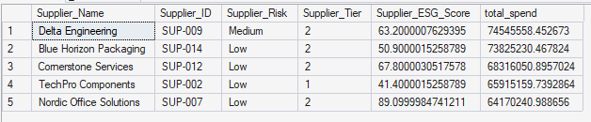
- Effectiveness of the "Preferred Supplier" policy: Is there a clear performance difference between preferred suppliers and occasional (non-preferred) suppliers? What proportion of total spending goes to single-source suppliers?
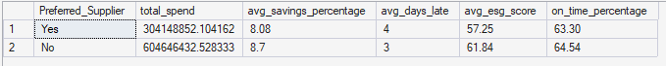
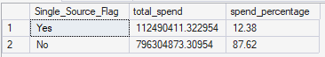
- OTIF (On-time Delivery): What is the average on-time delivery rate? Which suppliers or departments are experiencing the most severe delays?
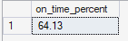
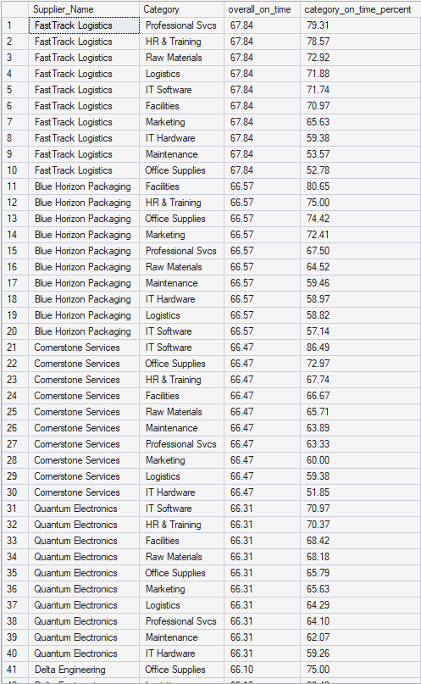
- Lead Time analysis: How does delivery lead time vary across different contract types? Is there any relationship between late deliveries and high-risk suppliers?
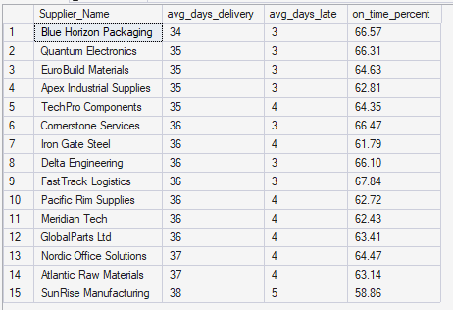
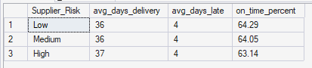
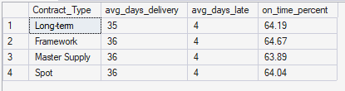
- Maverick Spend issue: How much off-contract (non-compliant) spending currently exists? How often are preferred suppliers being bypassed?
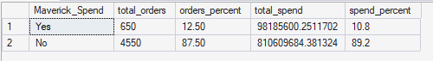
- Procure-to-Pay performance: How high are the overdue, disputed, and unmatched invoice rates? What are the critical risk indicators across the P2P cycle?
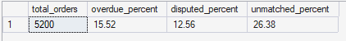
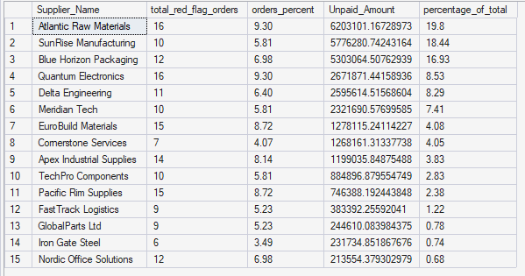
4. Dashboard in Tableu

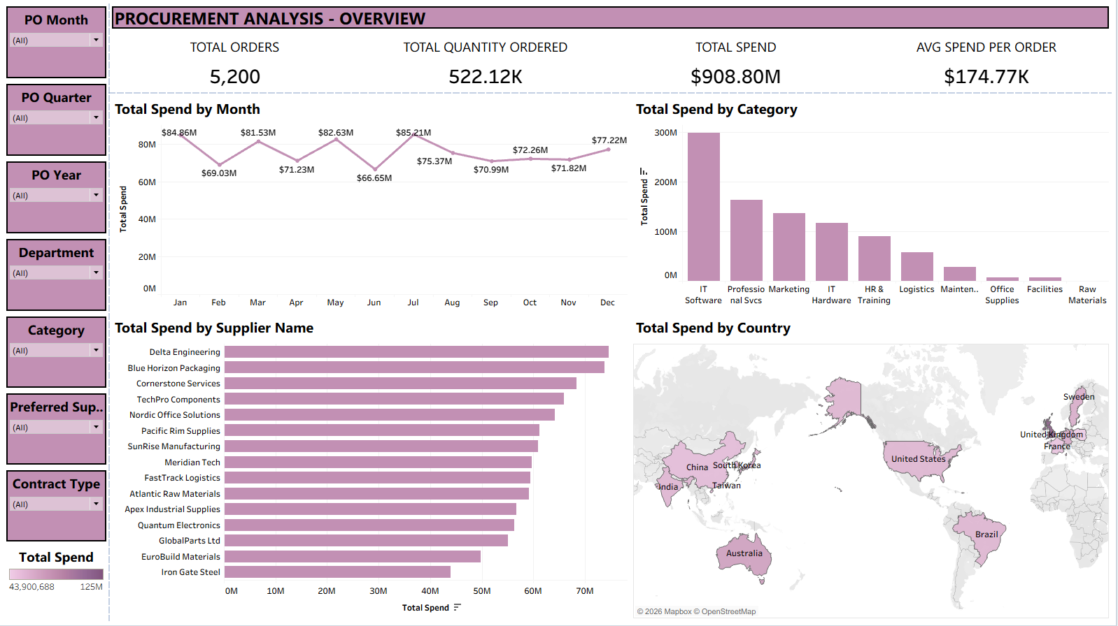
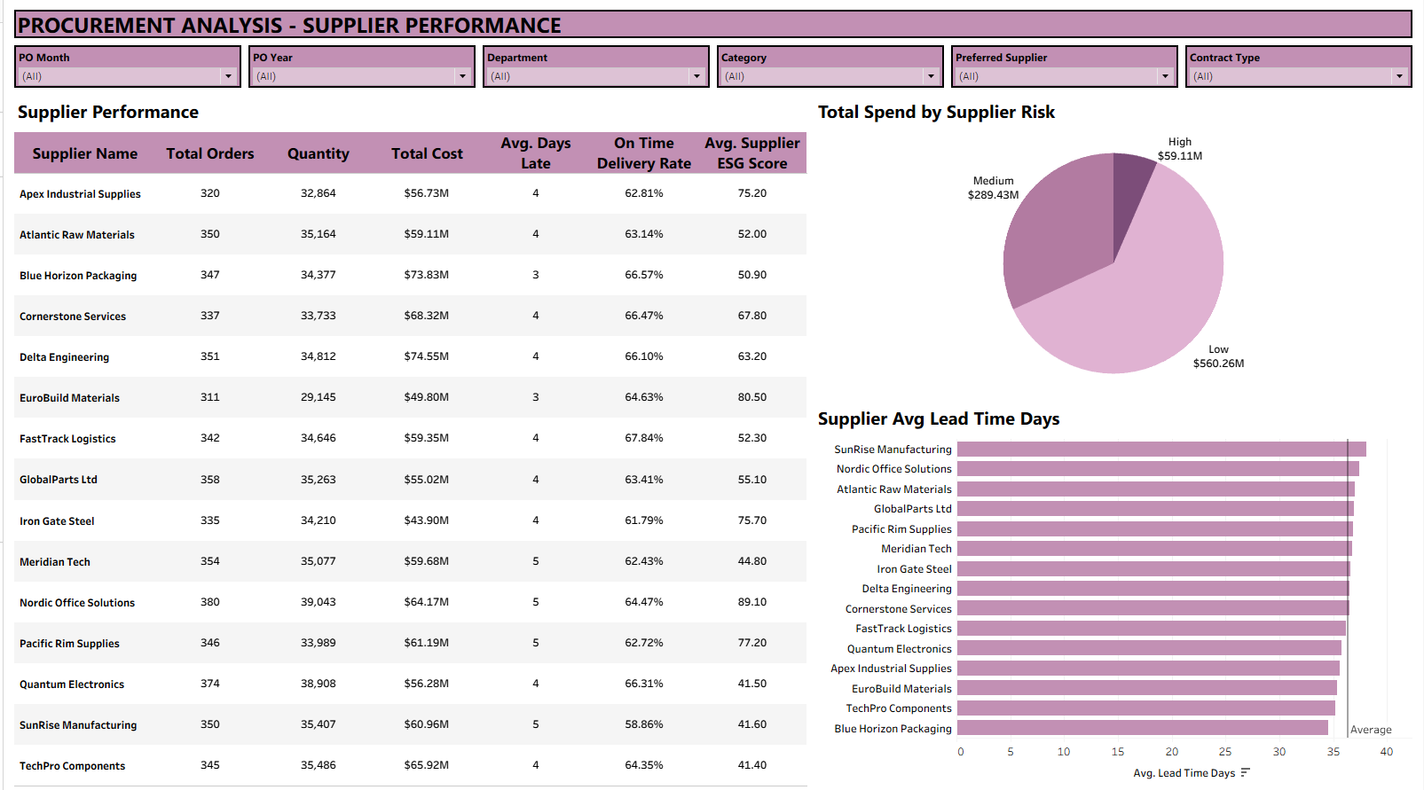
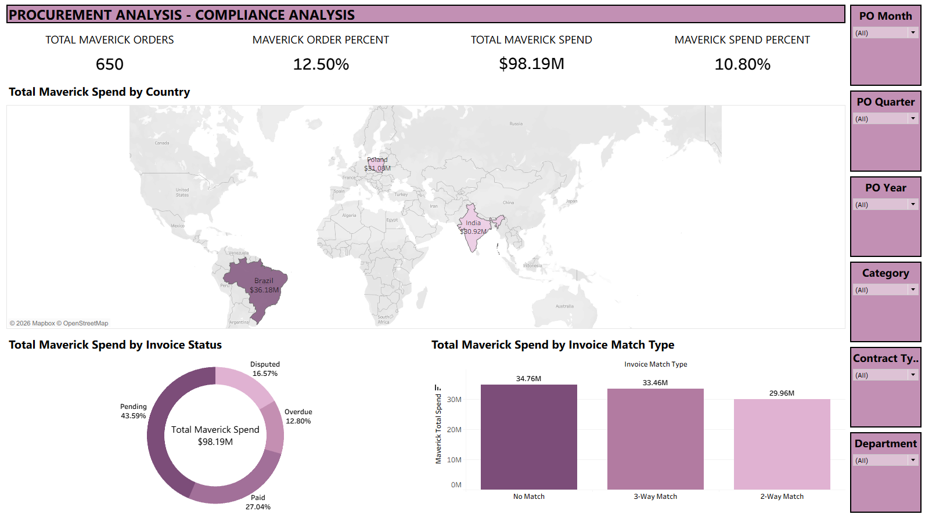
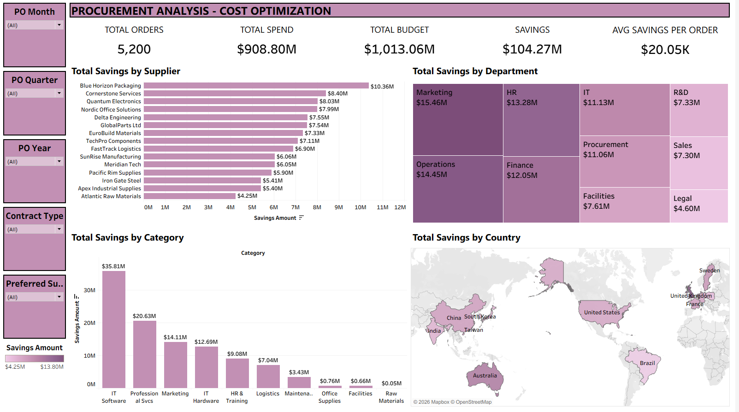
5. Insight
- The "Preferred Supplier" Paradox: A major anomaly is that non-preferred suppliers account for the majority of the budget, with over $604 million compared to $304 million from preferred suppliers. Furthermore, the non-preferred group significantly outperforms the preferred group: their average savings rate is 8.7% versus 8.08%. They also have fewer average days late, at 3 days compared to 4 days for preferred suppliers. Their ESG scores are higher, reaching 61.84 versus 57.25. Finally, the On-Time Delivery rate for the non-preferred group is slightly better.
- Imbalanced Contract Negotiation Effectiveness: Spot contracts are the primary driver of cost savings, accounting for 51.36% of total savings. In contrast, Long-term and Framework contracts only contribute 19.83% and 15.98%, respectively.
- Major Gaps in the P2P Process and Compliance: Maverick Spend accounts for 10.8% of total spending, equivalent to over $98.18 million across 650 orders. Payment risks within the system are severe, with 26.38% of invoices being unmatched. Additionally, 15.52% of invoices are overdue, and 12.56% are disputed. Notably, Atlantic Raw Materials represents an urgent risk with 16 red-flagged orders and over $6.2 million in unpaid amounts.
- Suboptimal On-Time Delivery Performance: The overall average on-time delivery rate is only 64.13%. Even the best-performing supplier on the list, FastTrack Logistics, only achieved an overall OTIF of 67.84%.
- Good Budget Control but Highly Concentrated Cash Flow: Most spending categories are well-controlled and remain under budget, with negative variances ranging from 9% to over 11.5%. However, IT Software and Professional Svcs are the two most capital-intensive categories in the system.
6. Business Recommendations
- Supplier optimization: Suppliers not in the priority group but with high ESG scores, short delivery times, and high savings rates should be upgraded to Priority status to establish strategic partnerships. Conversely, measures should be taken to gradually eliminate or reduce spending allocations to underperforming priority suppliers.
- Renegotiate Long-term Contracts: Relying too heavily on Spot contracts to optimize costs is unsustainable and poses risks of supply chain disruption. The organization needs to work with strategic suppliers to integrate volume-based tiering discounts into Long-term contracts, ensuring that preferential pricing aligns with long-term purchasing commitments.
- Tighten the Procure-to-Pay Process and Minimize Maverick Spend: Implement hard stops in the ERP system to reject payments without prior Purchase Order approval, aiming to push the Maverick Spend rate below a safe threshold. Deploy a synchronized 3-way matching process to eliminate the currently high unmatched invoice rate.
- Establish an Automated Risk Alert Dashboard: For better risk management, set up automated tracking workflows focused on monitoring supplier risks, alerting on budget deviations, and detecting sudden seasonal spending spikes.
- Incorporate Service Level Agreement into OTIF Penalty Clauses: Update Service Level Agreement terms with clear financial penalties for suppliers whose on-time delivery rates consistently fall below the 65% mark.

